Case Study Assignment   
SAP Customer Analysis: Royal Greenland

Part 1: Review Royal Greenland customer story materials

**Activity 1: Identify key stakeholders and explain their roles**

Key Stakeholders and their roles:

* SAP project team – expertise in designing, building and implementing SAP solutions, SAP methodologies and technologies, functional and industry expertise
* SAP AppHaus partner (Trifork) – application development expertise, integrating with SAP solutions, working with the SAP platform and ecosystem
* Royal Greenland stakeholders (IT, business, leadership) – subject matter experts and knowledge of processes, industry, organization, and technology landscape. Understanding their customers and end-users (fishing community). Signing off solution design, approach and project milestones.
* Royal Greenland customers (suppliers and consumers) – insight into the customer experience, validating design and process improvements
* End Users (fishing community) – expertise in fishing processes, knowledge of conditions, environmental and local community needs.

**Activity 2: Identify digital transformation goals**

Royal Greenland’s digital transformation goals include:

* **Automate processes** (catch registration, procurement, supply chain management processes)
* **Reduce errors or waste** (procurement data entry, optimize supply chain, etc.)
* **Business process improvement** **or efficiencies** (optimize internal processes and supply chain management to compete strongly and expand into new markets
* **Meet compliance and regulatory requirements** (catch registration, sustainability/stewardship of fisheries, quality control, accounting and tax compliance)
* **Improve customer engagement** (seafood consumers) through traceability and sustainability credentials
* **Capture and analyze data** to better inform business decisions and actions
* **Increase agility** by shifting to mobile (fishing communities can document their catch at sea without needing to fill in paperwork)
* **Reduce time to marke**t
* **Increase profits** for the fishing community and the company by simplifying selling processes

**Activity 3: Explain which digital transformation component is impacted**

There are three digital transformation components. In the Royal Greenland case, the main component impacted is **Business** **process transformation** (examples include optimizing the procurement process by automating data entry or digitizing catch registration). While Royal Greenland has shifted to a mobile-led approach and now has huge efficiencies in its operations, the underlying **business model** of supplying fish to consumers has not changed significantly. Similarly, while Royal Greenland is better able to predict procurement resourcing and engage with the fishing community, the **organizational structure** and **culture** have not been significantly impacted.

**Activity 4: Identify key metrics to demonstrate SAP solution value**

Key metrics that could demonstrate the value or success of the SAP implementation are:

* 70,000 purchase orders processed digitally instead of on paper
* 2,200 fishers readily adopted the mobile app
* 0 hours of training are required for fishers to use the mobile app
* Could also quantify the following as metrics:
* Fishers/Royal Greenland saving # hours for processing procurement transactions
* Increase of X% in supplier loyalty (that is, lower rate of supplier churn)
* X% increase in supplier loyalty contributes to increase % market share (Royal Greenland is more competitive)
* X% increase in reuse of data/information (providing insight for future development plans)
* X% decrease in data-entry errors
* Reduce time-to-market by X%

* * * * * * * * * * * * * * * * * * * * * * * * * * * * * * * * * * * * * * *

Part 2: Understand SAP BTP capabilities

**Activity 1: Identify the four main SAP BTP capabilities**

The four (4) main technology capabilities or components of SAP BTP are:

* Application Development
* Integration
* Data and Analytics
* Artificial Intelligence (AI)

**Activity 2: Identify the SAP BTP capabilities needed to achieve customer goals**

The main SAP BTP capabilities used to achieve Royal Greenland’s digital transformation goals are:

* Application Development – build cloud-native apps (mobile, web) that are user friendly and have high adoption rates (low training needs); leverages no-code or code-first development tools
* Integration – ease of integration between apps, third party and other systems (e.g., SAP HANA®, SAP ERP, SAP Supply Chain solution)
* Data and Analytics – leveraging data from catch registration to procurement, opportunities for further development (e.g. utilize GPS data captured to track ships lost at sea).

* * * * * * * * * * * * * * * * * * * * * * * * * * * * * * * * * * * * * * *

Part 3: Review the end-to-end SAP Solution

**Activity 1: Describe the end-to-end solution**

The end-to-end solution has the following components:

* SAP Business Technology Platform (SAP BTP) – the SAP Extension Suite was used to develop both native mobile and web apps. For the mobile apps, SAP BTP SDK iOS provides offline capabilities (e.g. so that the app can be used at sea without wifi), push notifications, authentication, device registration and logging etc.)
* Native mobile and Web apps
  + Mobile app (fishers use to submit catch registration, sign documents, validate sustainability certifications)
  + iPad app (capture more data for the catch data registration process e.g. seafood texture, quality, weight, temperature, etc.)
  + Web-based app (Royal Greenland procurement approvals)
* Data from apps integrates with:
  + SAP HANA®
  + SAP Integrated Business Planning for Supply Chain solution
  + SAP ERP application for data processing and storage (e.g. procurement data)

Source:[https://www.sap.com/about/customer-stories.html?search=royal+greenland&pdf-asset=cefd462d-f67d-0010-bca6-c68f7e60039b&page=4](https://www.sap.com/mena/about/customer-stories.html?search=royal+greenland&pdf-asset=cefd462d-f67d-0010-bca6-c68f7e60039b&page=4)

**Activity 2: Describe key system design and development considerations**

The project team will need to consider the following when building the end-to-end solution:

* **Computing Models** – the project team would need to consider how end users will interact with the solution. For example, fishers will be taking pictures, entering data about their catch, and digitally signing the Marine Stewardship Certificates through apps. The data from the apps then needs to be recorded and analyzed in procurement apps and systems by onshore operations staff. This means the solution must have both cloud and mobile computing elements. How data will be stored is also a consideration.
* **Architecture** – the project team would need to consider how the SAP BTP solution would be deployed – for example, will it be run on a private, public, hybrid, or multi-cloud environment? How will the cloud environment integrate with the mobile apps and the on-prem systems (for example, SAP ERP)? The project team should also consider how data architecture, flow, and volume would influence these choices. For example, when fishers use the apps at sea, will data be captured offline with batch uploads to the cloud, or with real-time connectivity to the cloud?
* **Operating Systems and Platforms** – the project team would need to consider the compatibility between devices and apps across the solution, including cloud, mobile, on-prem, and any third-party systems. Using a Platform as a Service (PaaS) solution such as SAP BTP will create a unified environment and simplify app development.
* **Application Development** - the apps need to be consumer grade and fit for purpose, for example, the mobile app will need to work offline at sea in unpredictable conditions. The apps need to be easy to use so that they can be adopted quickly by fishers with minimal training. The project team will need to consider how the type and volume of data (for example, images, catch details) being captured influences the design and the connections to other parts of the solution. Ease of upgrades and integration to third-party services (for example, digital signatures, GPS data) are also important.
* **Programming languages** – the project team would need to consider which programming languages are fit for function in the scenario – for example, the language used to develop the web app may be different from the language used to develop the mobile app for fishers or the cloud services. Ease of maintenance and speed is also important so ‘no-code’ or code-first development tools should be considered.
* **Data analytics** – consider what type of data will need to be captured and analyzed (for example images, seafood parameters, e-Signatures). What the implications for processing and storage? Who has custody of the data at each stage as it flows through the solution?
* **Security** – the project team would need to consider elements such as user access, authentication, and authorization. They would also need to consider data integrity along the entire data flow – that is, can data be interfered with or intercepted? There would also be specific data privacy and compliance considerations as Royal Greenland operate in the European Union.

**Activity 3: Draw a diagram to show how data flows through the solution**

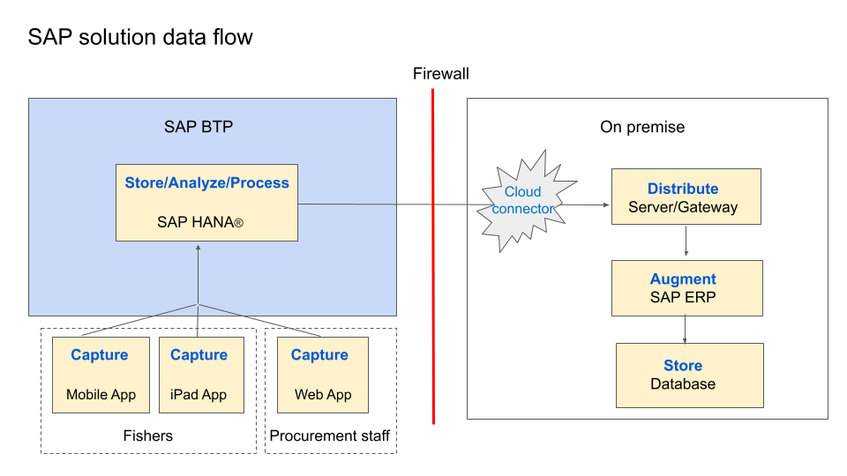

**Activity 4: Describe technology areas impacted by further development**

SAP BTP is an open platform that can be easily extended to integrate with other SAP products and third-party services. SAP Commerce Cloud or a third-party eCommerce solution could be an extension of the SAP BTP platform. SAP BTP platform makes it easy to develop apps that integrate with existing solutions – for example, Royal Greenland could enhance the catch registration app to utilize the GPS data they are collecting as part of catch registration to help authorities find boats that are lost at sea. Technology areas that could be impacted in these scenarios are Application Development, Integration, and Security.

* * * * * * * * * * * * * * * * * * * * * * * * * * * * * * * * * * * * * * *

Part 4: Assess how the SAP solution supports digital transformation

**Activity 1: Describe how SAP BTP supports customer digital transformation goals**

SAP BTP provides a unified platform environment that simplifies application development and brings apps, devices, and systems together seamlessly along with powerful analytics capability. This enables Royal Greenland to digitize the entire process from catch registration, to procurement, and factory processing onshore, along with quality control and distribution. Implementing SAP BTP helps increase Royal Greenland’s agility by shifting to a mobile-first approach (fishers can document their catch at sea without needing to fill in paperwork). This will increase profits for the fishing community and the company by simplifying selling processes and reducing time to market.

Implementing an SAP solution also supports the goal to attract more consumers by providing product traceability from sea to table. Catch registration and the ability to digitally sign Marine Stewardship Certificates through user-friendly apps helps Royal Greenland meet compliance and regulatory requirements more easily, and supports the sustainability of fisheries. Stronger analytics and processing capabilities through SAP HANA® means Royal Greenland can capture and analyze data to better inform its business decisions and future plans for development.

**Activity 2: Identify how SAP solution contributes to quadruple bottom line (4Ps)**

| **People** | **Planet** | **Profit** | **Purpose** |
| --- | --- | --- | --- |
| Ease of use of mobile and web apps (no training requirements)  Better resource planning for procurement centers  Support and invest in local fishing communities | Support sustainable business model in a sensitive marine environment  Capture data to comply with national quotas and sustainability requirements, ensuring fish are ethically sourced. | Improve profits to fishing communities (e.g. recording Marine Stewardship Council certifications in apps enable fishers to charge higher prices)  Savings from process improvements and operations efficiencies for Royal Greenland (e.g. procurement resourcing, reduced data entry errors)  Reduce time to market and increase competitiveness | Product tracing from sea to table, helping consumers choose ethically sourced products  Support and invest in local fishing communities  Promote sustainable fishing practices |